ITUE203: WEB DEVELOPMENT FRAMEWORKS 25CS106– Yana


Faculty of Technology and Engineering

Chandubhai S. Patel Institute of Technology (CSPIT) Department of Computer Science & Engineering

Laboratory manual
Academic Year | : | 2026-27 | Semester | : | 3rd

Practical - 04

PROBLEM STATEMENT :
Add dynamic UI components such as collapsible FAQ, modal popup, image/content slider, notification banner, hamburger menu, and light/dark
theme switcher using JavaScript.
OBJECTIVE:
To develop an interactive and user-friendly web interface using JavaScript DOM manipulation and event handling, by implementing dynamic features such as a collapsible FAQ, modal popup, content slider, notification banner, hamburger menu, and light/dark theme switcher, along with localStorage to save user preferences.
CODE:
HTML:
<!DOCTYPE html>
<html lang="en">

<head>
<meta charset="UTF-8">
<meta name="viewport" content="width=device-width, initial-scale=1.0">

<title>StudentHub | Dashboard</title>

<link href="https://cdn.jsdelivr.net/npm/bootstrap@5.3.7/dist/css/bootstrap.min.css" rel="stylesheet">

<link rel="stylesheet" href="css/style.css">
</head>

<body>

<!-- Skip Link -->
<a href="#main-content">Skip to Main Content</a>

<!-- =========================
Header
========================== -->

<header>

<img src="images/logo.jpeg"
alt="StudentHub Portal Logo"
width="80">

<h1>StudentHub Portal</h1>

<p>Your Gateway to Academic Services</p>

</header>

<!-- =========================
Main Navigation
========================== -->
<button id="menuButton">☰</button>
<nav id="mainNav" aria-label="Main Navigation">

<a href="index.html">Home</a>

<a href="dashboard.html" aria-current="page">Dashboard</a>

<a href="overview.html">Overview</a>

<a href="attendance.html">Attendance</a>

<a href="assignments.html">Assignments</a>

<a href="events.html">Events</a>

<a href="hall-ticket.html">Hall Ticket</a>

<a href="holidays.html">Holidays</a>

<a href="lost-found.html">Lost & Found</a>

<a href="suggestions.html">Suggestions</a>

<a href="login.html">Login</a>

<!-- Practical 4 buttons -->

<button id="themeToggle">🌙 Dark Mode</button>

<button id="menuButton">☰</button>

</nav>

<!-- =========================
Notification Banner
========================== -->

<div id="notification" class="notification">

<span>📢 New StudentHub event registration is open!</span>

<button id="closeNotification" aria-label="Close notification">
×
</button>

</div>

<!-- =========================
Main Content
========================== -->

<main id="main-content">

<!-- Dashboard Welcome -->

<section>

<h2>Student Dashboard</h2>

<p>
Welcome to your dashboard. Here you can access all academic
services and student information.
</p>

</section>

<!-- Dashboard Features -->

<section>

<h2>Dashboard Features</h2>

<article>

<h3>Attendance</h3>

<p>
View your attendance records and percentage.
</p>

</article>

<article>

<h3>Assignments</h3>

<p>
Check pending and submitted assignments.
</p>

</article>

<article>

<h3>Events</h3>

<p>
View upcoming college events and activities.
</p>

</article>

</section>

<!-- =========================
Modal Button
========================== -->

<section>

<h2>Upcoming Event</h2>

<p>
Get information about upcoming StudentHub events.
</p>

<button id="openModal">
View Event Details
</button>

</section>

<!-- =========================
Content Slider
========================== -->

<section>

<h2>Student Events</h2>

<div class="slider">

<div class="slide active">

<h2>Technical Event</h2>

<p>
Join our technical event and improve your skills.
</p>

</div>

<div class="slide">

<h2>Sports Event</h2>

<p>
Participate in exciting sports activities.
</p>

</div>

<div class="slide">

<h2>Cultural Event</h2>

<p>
Show your talent and participate in cultural activities.
</p>

</div>

<button id="prevSlide">
Previous
</button>

<button id="nextSlide">
Next
</button>

</div>

</section>

<!-- =========================
FAQ
========================== -->

<section class="faq">

<h2>Frequently Asked Questions</h2>

<div class="faq-item">

<button class="faq-question">

What is StudentHub?

</button>

<div class="faq-answer">

<p>
StudentHub is a platform for managing student
activities and information.
</p>

</div>

</div>

<div class="faq-item">

<button class="faq-question">

How can I register for an event?

</button>

<div class="faq-answer">

<p>
You can register for available events from the
Events section.
</p>

</div>

</div>

<div class="faq-item">

<button class="faq-question">

Can I update my profile?

</button>

<div class="faq-answer">

<p>
Yes, you can update your profile information from
the Profile page.
</p>

</div>

</div>

</section>

<!-- =========================
Quick Access
========================== -->

<aside>

<h2>Quick Access</h2>

<ul>

<li>
<a href="attendance.html">
Attendance
</a>
</li>

<li>
<a href="assignments.html">
Assignments
</a>
</li>

<li>
<a href="events.html">
Events
</a>
</li>

<li>
<a href="hall-ticket.html">
Hall Ticket
</a>
</li>

</ul>

</aside>

</main>

<!-- =========================
Modal Popup
========================== -->

<div id="eventModal" class="modal">

<div class="modal-content">

<button id="closeModal" aria-label="Close event details">
×
</button>

<h2>StudentHub Event</h2>

<p>
Join our upcoming student event and participate in
various activities.
</p>

</div>

</div>

<!-- =========================
Footer
========================== -->

<footer>

<p>
&copy; 2026 StudentHub Portal |
Developed for Web Technology Practical
</p>

</footer>

<!-- Bootstrap -->

<script src="https://cdn.jsdelivr.net/npm/bootstrap@5.3.7/dist/js/bootstrap.bundle.min.js"></script>

<!-- Your JavaScript -->

<script src="js/script.js"></script>

</body>

</html>

CSS:
/* =========================
General Styles
========================= */

* {
margin: 0;
padding: 0;
box-sizing: border-box;
}

body {
font-family: Arial, Helvetica, sans-serif;
line-height: 1.6;
background-color: #f4f6f9;
color: #333;
transition: background-color 0.3s ease, color 0.3s ease;
}

img {
max-width: 100%;
height: auto;
}

/* =========================
Skip Link
========================= */

a[href="#main-content"] {
position: absolute;
left: -9999px;
}

a[href="#main-content"]:focus {
left: 20px;
top: 20px;
background: yellow;
padding: 10px;
z-index: 1000;
}

/* =========================
Header
========================= */

header {
background-color: #0d6efd;
color: white;
text-align: center;
padding: 20px;
}

header img {
border-radius: 50%;
margin-bottom: 10px;
}

header h1 {
margin-bottom: 10px;
}

/* =========================
Navigation
========================= */

nav {
background-color: #212529;
display: flex;
justify-content: center;
flex-wrap: wrap;
gap: 12px;
padding: 15px;
}

nav a {
color: white;
text-decoration: none;
padding: 8px 12px;
border-radius: 5px;
}

nav a:hover,
nav a[aria-current="page"] {
background-color: #0d6efd;
}

/* =========================
Main Layout
========================= */

main {
display: grid;
grid-template-columns: 3fr 1fr;
gap: 20px;
max-width: 1200px;
margin: 20px auto;
padding: 20px;
}

section {
background: white;
padding: 20px;
border-radius: 10px;
margin-bottom: 20px;
}

article {
background: #f8f9fa;
padding: 15px;
margin-top: 15px;
border-left: 5px solid #0d6efd;
border-radius: 5px;
}

aside {
background: white;
padding: 20px;
border-radius: 10px;
height: fit-content;
}

aside ul {
list-style: none;
}

aside li {
margin: 10px 0;
}

aside a {
text-decoration: none;
color: #0d6efd;
}

footer {
background: #212529;
color: white;
text-align: center;
padding: 15px;
margin-top: 20px;
}

/* =========================
PRACTICAL 4
Theme Switcher
========================= */

body.dark-mode {
background-color: #121212;
color: #f5f5f5;
}

body.dark-mode section {
background-color: #1e1e1e;
color: #f5f5f5;
}

body.dark-mode article {
background-color: #252525;
color: #f5f5f5;
}

body.dark-mode aside {
background-color: #1e1e1e;
color: #f5f5f5;
}

body.dark-mode footer {
background-color: #000;
}

body.dark-mode .slide {
background-color: #252525;
color: #f5f5f5;
}

/* Theme Button */

#themeToggle {
border: none;
background-color: white;
color: #333;
padding: 8px 12px;
border-radius: 5px;
cursor: pointer;
}

#themeToggle:hover {
background-color: #e9ecef;
}

/* =========================
Hamburger Menu
========================= */

#menuButton {
display: none;
border: none;
background-color: #0d6efd;
color: white;
padding: 8px 12px;
border-radius: 5px;
cursor: pointer;
}

#menuButton:hover {
background-color: #0b5ed7;
}

/* =========================
Notification
========================= */

.notification {
display: flex;
justify-content: space-between;
align-items: center;

max-width: 1200px;
margin: 20px auto;

padding: 12px 18px;

background-color: #e7f1ff;
color: #084298;

border-left: 5px solid #0d6efd;
border-radius: 6px;
}

.notification button {
border: none;
background: transparent;
color: inherit;
font-size: 22px;
cursor: pointer;
}

/* =========================
Modal
========================= */

.modal {
display: none;

position: fixed;

top: 0;
left: 0;

width: 100%;
height: 100%;

background-color: rgba(0, 0, 0, 0.65);

justify-content: center;
align-items: center;

z-index: 2000;
}

.modal.show {
display: flex;
}

.modal-content {
position: relative;

width: 400px;
max-width: 90%;

padding: 30px;

background-color: white;
color: #333;

border-radius: 10px;

animation: modalAppear 0.3s ease;
}

#closeModal {
position: absolute;

top: 8px;
right: 12px;

border: none;
background: transparent;

font-size: 25px;
cursor: pointer;
}

@keyframes modalAppear {

from {
opacity: 0;
transform: scale(0.9);
}

to {
opacity: 1;
transform: scale(1);
}
}

/* =========================
FAQ
========================= */

.faq {
margin-top: 20px;
}

.faq-item {
margin-bottom: 10px;
}

.faq-question {
width: 100%;

padding: 14px;

border: none;
border-radius: 5px;

background-color: #0d6efd;
color: white;

text-align: left;

cursor: pointer;

font-size: 16px;
}

.faq-question:hover {
background-color: #0b5ed7;
}

.faq-answer {
display: none;

padding: 15px;

background-color: #f8f9fa;
color: #333;

border: 1px solid #ddd;
}

.faq-answer.show {
display: block;
}

body.dark-mode .faq-answer {
background-color: #252525;
color: white;
}

/* =========================
Slider
========================= */

.slider {
position: relative;

overflow: hidden;

margin-top: 20px;
}

.slide {
display: none;

padding: 30px;

text-align: center;

background-color: #f8f9fa;

border-radius: 10px;

animation: slideFade 0.4s ease;
}

.slide.active {
display: block;
}

.slide h2 {
color: #0d6efd;
margin-bottom: 10px;
}

/* Slider Buttons */

#prevSlide,
#nextSlide {
border: none;

padding: 9px 16px;

margin: 12px 5px;

border-radius: 5px;

background-color: #0d6efd;

color: white;

cursor: pointer;
}

#prevSlide:hover,
#nextSlide:hover {
background-color: #0b5ed7;
transform: translateY(-2px);
}

/* Slider Animation */

@keyframes slideFade {

from {
opacity: 0;
transform: translateX(15px);
}

to {
opacity: 1;
transform: translateX(0);
}
}

/* =========================
Buttons
========================= */

button {
transition: transform 0.2s ease,
background-color 0.2s ease;
}

button:focus-visible,
a:focus-visible {
outline: 3px solid #ffc107;
outline-offset: 2px;
}

/* =========================
Responsive Design
========================= */

@media (max-width: 768px) {

main {
grid-template-columns: 1fr;
}

header {
padding: 15px;
}

section,
aside {
margin-bottom: 15px;
}

/* Hamburger */

#menuButton {
display: block;
}

#mainNav {
display: none;
flex-direction: column;
align-items: center;
}

#mainNav.show {
display: flex;
}

#mainNav a {
width: 100%;
text-align: center;
}

/* Notification */

.notification {
margin: 15px 10px;
}

/* Modal */

.modal-content {
width: 90%;
}

}

@media (max-width: 576px) {

body {
font-size: 15px;
}

header h1 {
font-size: 1.8rem;
}

header p {
font-size: 0.9rem;
}

main {
padding: 10px;
}

section,
article,
aside {
padding: 15px;
}

footer {
font-size: 14px;
}

}
#menuButton {
display: none;
}

@media (max-width: 768px) {

#menuButton {
display: block;
margin: 10px auto;
padding: 10px 15px;
font-size: 24px;
background: #212529;
color: white;
border: none;
border-radius: 5px;
cursor: pointer;
}

#mainNav {
display: none;
flex-direction: column;
}

#mainNav.show {
display: flex;
}

#mainNav a,
#mainNav button {
width: 100%;
text-align: center;
}
}

JAVASCRIPT:
// =========================
// 1. Light / Dark Theme
// =========================

const themeToggle = document.getElementById("themeToggle");

if (themeToggle) {

const savedTheme = localStorage.getItem("theme");

if (savedTheme === "dark") {
document.body.classList.add("dark-mode");
themeToggle.textContent = "☀️ Light Mode";
}

themeToggle.addEventListener("click", function () {

document.body.classList.toggle("dark-mode");

if (document.body.classList.contains("dark-mode")) {

localStorage.setItem("theme", "dark");

themeToggle.textContent = "☀️ Light Mode";

} else {

localStorage.setItem("theme", "light");

themeToggle.textContent = "🌙 Dark Mode";

}

});

}

// =========================
// 2. Hamburger Menu
// =========================

const menuButton = document.getElementById("menuButton");

const mainNav = document.getElementById("mainNav");

if (menuButton && mainNav) {

menuButton.addEventListener("click", function () {

mainNav.classList.toggle("show");

});

}

// =========================
// 3. FAQ
// =========================

const faqQuestions = document.querySelectorAll(".faq-question");

faqQuestions.forEach(function (question) {

question.addEventListener("click", function () {

const answer = question.nextElementSibling;

answer.classList.toggle("show");

});

});

// =========================
// 4. Modal Popup
// =========================

const openModal = document.getElementById("openModal");

const closeModal = document.getElementById("closeModal");

const eventModal = document.getElementById("eventModal");

if (openModal && closeModal && eventModal) {

openModal.addEventListener("click", function () {

eventModal.classList.add("show");

});

closeModal.addEventListener("click", function () {

eventModal.classList.remove("show");

});

eventModal.addEventListener("click", function (event) {

if (event.target === eventModal) {

eventModal.classList.remove("show");

}

});

}

// =========================
// 5. Notification
// =========================

const notification = document.getElementById("notification");

const closeNotification =
document.getElementById("closeNotification");

if (notification && closeNotification) {

closeNotification.addEventListener("click", function () {

notification.style.display = "none";

});

}

// =========================
// 6. Content Slider
// =========================

const slides = document.querySelectorAll(".slide");

const nextSlide = document.getElementById("nextSlide");

const prevSlide = document.getElementById("prevSlide");

let currentSlide = 0;

function showSlide(index) {

slides.forEach(function (slide) {

slide.classList.remove("active");

});

slides[index].classList.add("active");

}

if (nextSlide && prevSlide && slides.length > 0) {

nextSlide.addEventListener("click", function () {

currentSlide++;

if (currentSlide >= slides.length) {

currentSlide = 0;

}

showSlide(currentSlide);

});

prevSlide.addEventListener("click", function () {

currentSlide--;

if (currentSlide < 0) {

currentSlide = slides.length - 1;

}

showSlide(currentSlide);

});

}

OUTPUT:
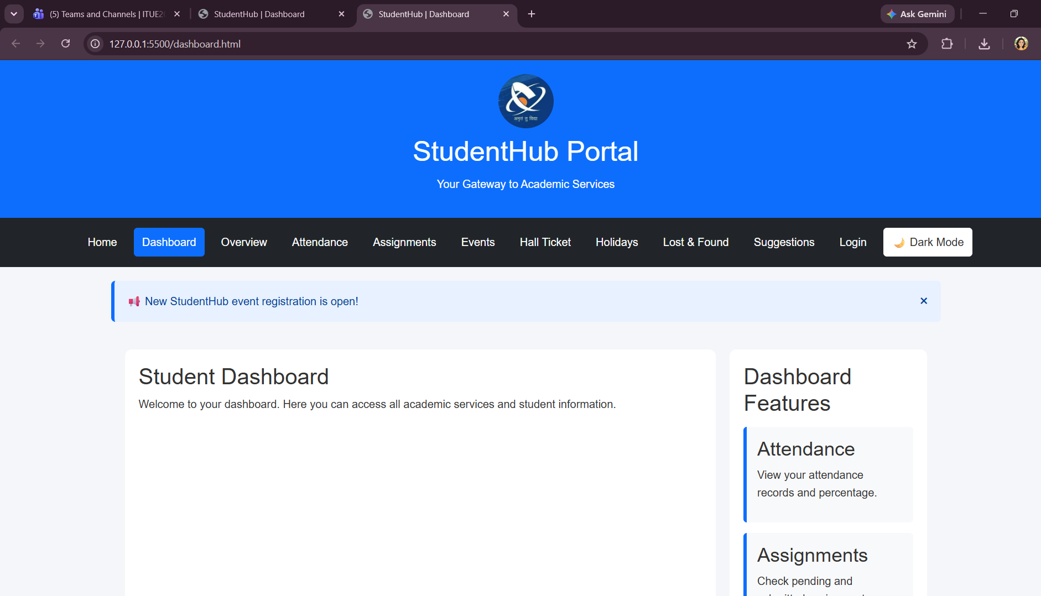
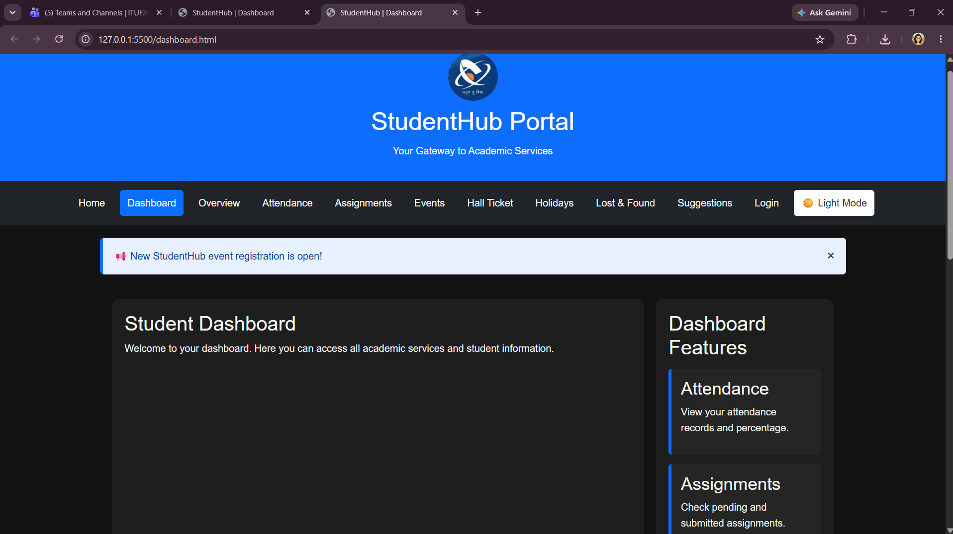
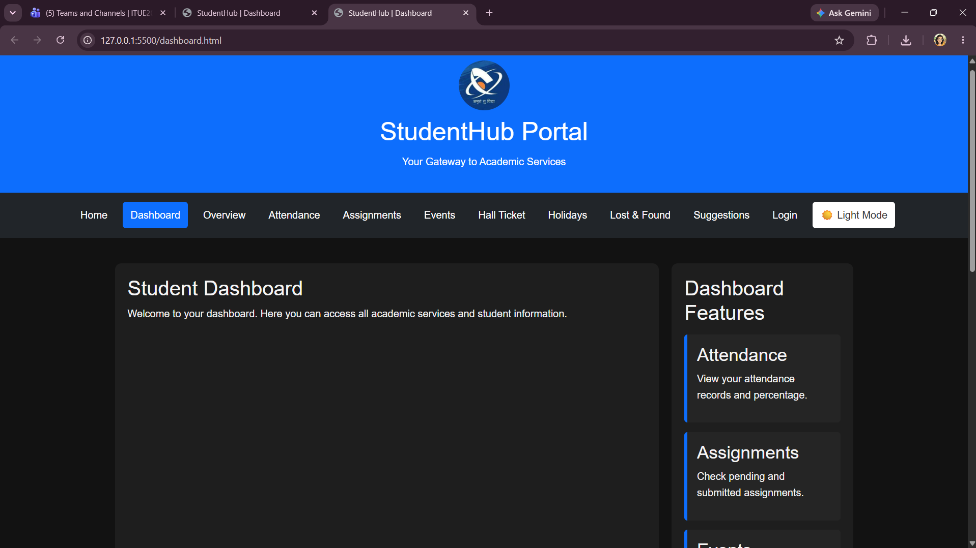
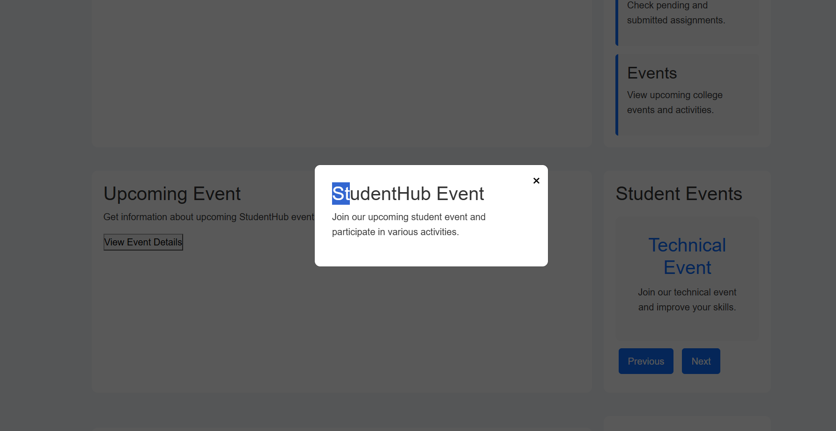
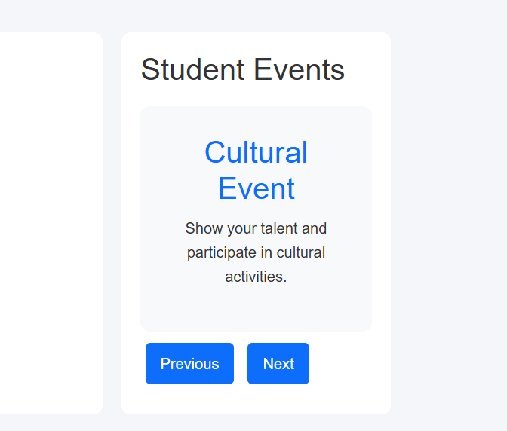
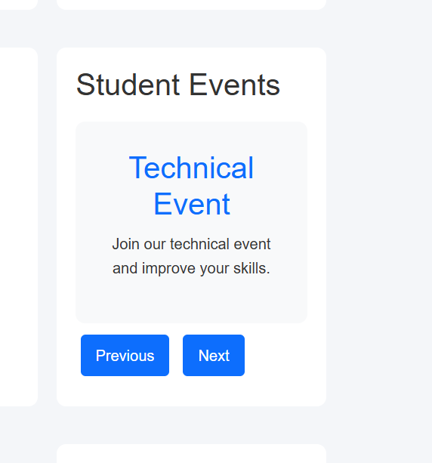
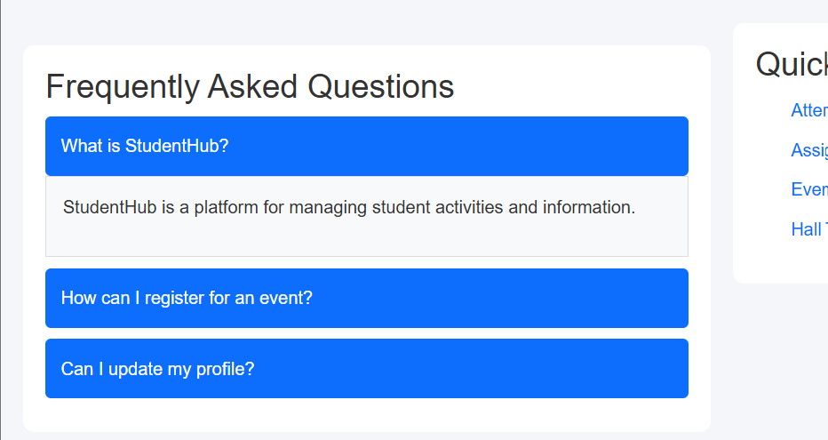
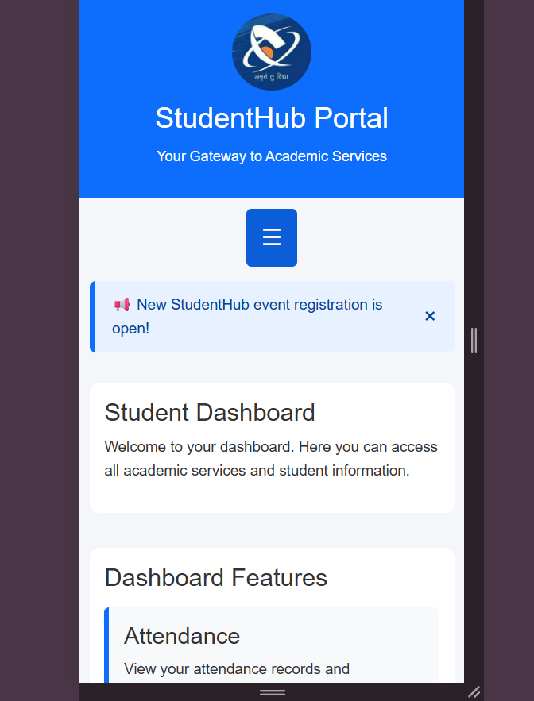

LEARNING OUTCOME:
To understand and apply JavaScript DOM manipulation, event handling, class manipulation, localStorage, and basic animations to create dynamic, interactive, and user-friendly web interfaces. Students will be able to enhance web pages with client-side interactivity and improve the overall user experience.

